於ChatGPT詢問「write python to solve linear regression problem」

ChatGPT回覆以下步驟

### **Step 1: Install Necessary Libraries**

If you haven't already, you need to install the required libraries. You can do this via pip:

| pip install numpy pandas scikit-learn matplotlib |
| --- |

### **Step 2: Import Libraries**

| import numpy as np  import pandas as pd  import matplotlib.pyplot as plt  from sklearn.model_selection import train_test_split  from sklearn.linear_model import LinearRegression |
| --- |

### **Step 3: Create a Sample Dataset**

For this example, let's create a simple synthetic dataset:

| # Generate synthetic data  np.random.seed(0)  X = 2 * np.random.rand(100, 1)  y = 4 + 3 * X + np.random.randn(100, 1) # Linear relation with some noise  # Convert to pandas DataFrame for easier manipulation  data = pd.DataFrame(data=np.hstack((X, y)), columns=["Feature", "Target"]) |
| --- |

### **Step 4: Split the Dataset**

Next, we’ll split the dataset into training and testing sets:

| # Split the dataset into training and testing sets  X_train, X_test, y_train, y_test = train_test_split(data[["Feature"]], data["Target"], test_size=0.2, random_state=42) |
| --- |

### **Step 5: Create and Train the Model**

Now we can create a linear regression model and train it:

| # Create a linear regression model  model = LinearRegression()  # Train the model  model.fit(X_train, y_train) |
| --- |

### **Step 6: Make Predictions**

After training the model, we can make predictions on the test set:

| # Make predictions  y_pred = model.predict(X_test) |
| --- |

### **Step 7: Evaluate the Model**

We can evaluate the model's performance by calculating the R² score:＝

| # Evaluate the model  r_squared = model.score(X_test, y_test)  print(f"R² score: {r_squared:.2f}") |
| --- |

### **Step 8: Visualize the Results**

Finally, we can visualize the results:

| # Plot the results  plt.scatter(X_test, y_test, color='blue', label='Actual Data')  plt.scatter(X_test, y_pred, color='red', label='Predicted Data')  plt.plot(X_test, y_pred, color='red', linewidth=2)  plt.xlabel('Feature')  plt.ylabel('Target')  plt.title('Linear Regression Results')  plt.legend()  plt.show() |
| --- |

### **Complete Code**

Here’s the complete code combined:

| import numpy as np  import pandas as pd  import matplotlib.pyplot as plt  from sklearn.model_selection import train_test_split  from sklearn.linear_model import LinearRegression  # Generate synthetic data  np.random.seed(0)  X = 2 * np.random.rand(100, 1)  y = 4 + 3 * X + np.random.randn(100, 1) # Linear relation with some noise  data = pd.DataFrame(data=np.hstack((X, y)), columns=["Feature", "Target"])  # Split the dataset into training and testing sets  X_train, X_test, y_train, y_test = train_test_split(data[["Feature"]], data["Target"], test_size=0.2, random_state=42)  # Create a linear regression model  model = LinearRegression()  # Train the model  model.fit(X_train, y_train)  # Make predictions  y_pred = model.predict(X_test)  # Evaluate the model  r_squared = model.score(X_test, y_test)  print(f"R² score: {r_squared:.2f}")  # Plot the results  plt.scatter(X_test, y_test, color='blue', label='Actual Data')  plt.scatter(X_test, y_pred, color='red', label='Predicted Data')  plt.plot(X_test, y_pred, color='red', linewidth=2)  plt.xlabel('Feature')  plt.ylabel('Target')  plt.title('Linear Regression Results')  plt.legend()  plt.show() |
| --- |

### **Explanation**

* **Data Generation**: We create synthetic data that follows a linear relationship with some added noise.
* **Model Training**: We use LinearRegression to fit the model to the training data.
* **Evaluation**: The R² score provides insight into how well the model explains the variability of the target variable.
* **Visualization**: A scatter plot shows actual vs. predicted values, allowing us to visually assess the model’s performance.

Feel free to modify the dataset or parameters to explore further!

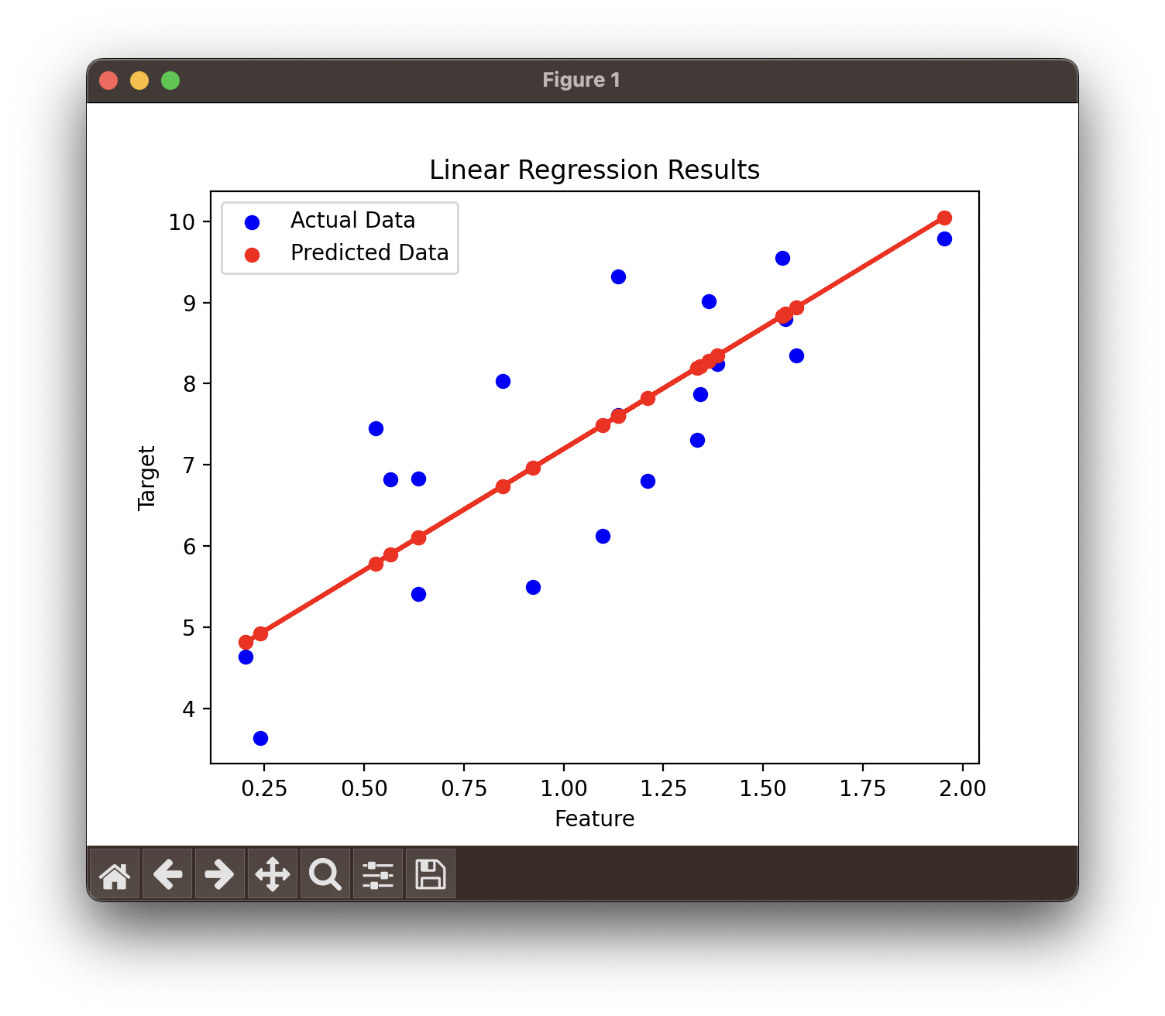

我請ChatGPT 轉換一下  
「​​​​​​convert this code to streamlit (don't use Matplotlib)」

他回答

Sure! Below is an example of how to convert the linear regression code into a Streamlit app without using Matplotlib for visualization. Instead, we'll use Streamlit's built-in plotting capabilities to display the regression line and predictions.

### **Step 1: Install Streamlit**

If you haven't installed Streamlit yet, you can do so using pip:

| pip install streamlit |
| --- |

### **Step 2: Create a Streamlit App**

You can create a file named app.py and include the following code:

| import numpy as np  import pandas as pd  import streamlit as st  from sklearn.model_selection import train_test_split  from sklearn.linear_model import LinearRegression  import plotly.express as px  # Generate synthetic data  np.random.seed(0)  X = 2 * np.random.rand(100, 1)  y = 4 + 3 * X + np.random.randn(100, 1) # Linear relationship with some noise  data = pd.DataFrame(data=np.hstack((X, y)), columns=["Feature", "Target"])  # Streamlit app title  st.title("Linear Regression with Streamlit")  # Display the dataset  if st.checkbox("Show dataset"):  st.write(data)  # Split the dataset into training and testing sets  X_train, X_test, y_train, y_test = train_test_split(data[["Feature"]], data["Target"], test_size=0.2, random_state=42)  # Create and train the model  model = LinearRegression()  model.fit(X_train, y_train)  # Make predictions  y_pred = model.predict(X_test)  # Create a DataFrame for predictions, fixing the dimension issue  predictions = pd.DataFrame(data=np.hstack((X_test, y_test.values.reshape(-1, 1), y_pred.reshape(-1, 1))), columns=["Feature", "Actual", "Predicted"])  # Plotting  fig = px.scatter(predictions, x="Feature", y="Actual", title="Actual vs Predicted",  labels={"Actual": "Actual Target", "Feature": "Feature"}, color="Predicted")  fig.add_scatter(x=predictions["Feature"], y=predictions["Predicted"], mode='lines', name='Regression Line', line=dict(color='red'))  # Display the plot  st.plotly_chart(fig)  # Evaluate the model  r_squared = model.score(X_test, y_test)  st.write(f"R² score: {r_squared:.2f}") |
| --- |

### **Step 3: Run the Streamlit App**

**In your terminal, navigate to the directory where app.py is located and run:**

| streamlitrun app.py |
| --- |

### **Explanation**

* Data Generation: We create synthetic data similar to the previous example.
* Streamlit Components:
  + st.title() sets the title of the app.
  + st.checkbox() allows users to show/hide the dataset.
  + st.write() displays text and data frames.
* Plotly for Visualization: We use plotly.express to create interactive scatter plots, which can be used in place of Matplotlib.
* Model Evaluation: The R² score is calculated and displayed.

### **Additional Notes**

* Make sure you have the plotly library installed as well. If you don't, you can install it using:

| pip install plotly |
| --- |

Now you should have a functional Streamlit app for linear regression without using Matplotlib! If you have any further questions or need more features, feel free to ask!



我請ChatGPT 優化一下

「combine all figures in one figure, and show the regression line in red, modify the code to set y = a * X + 50+C*np.random.rand(n, 1), where a is -10 to 10, c is 0 to 100, n is number of points 10 to 500, allow user to input a, c, n as slider.」

他回答

To create a Streamlit application that combines all figures into one and allows user input via sliders for the parameters aa, cc, and nn, while also showing the regression line in red, you can use the following code:

### **Complete Streamlit Code**

| import numpy as np  import pandas as pd  import streamlit as st  import sklearn.linear_model  import plotly.express as px  # Title of the app  st.title("Linear Regression with Adjustable Parameters")  # Sliders for user input  a = st.slider("Select value for a (slope):", -10.0, 10.0, 0.0)  c = st.slider("Select value for c (constant):", 0.0, 100.0, 50.0)  n = st.slider("Select number of points (n):", 10, 500, 100)  # Generating the dataset  np.random.seed(42) # For reproducibility  X = np.random.rand(n, 1) * 100 # Random X values from 0 to 100  y = a * X + 50 + c * np.random.rand(n, 1) # Linear relation with noise  # Create a linear regression model  model = sklearn.linear_model.LinearRegression()  model.fit(X, y)  y_pred = model.predict(X)  # Create a DataFrame for visualization  data = pd.DataFrame({'X': X.flatten(), 'Actual': y.flatten(), 'Predicted': y_pred.flatten()})  # Create a plot using Plotly  fig = px.scatter(data, x='X', y='Actual', title='Linear Regression', labels={'X': 'Feature', 'Actual': 'Target'})  fig.add_scatter(x=data['X'], y=data['Predicted'], mode='lines', name='Regression Line', line=dict(color='red'))  # Show the plot in Streamlit  st.plotly_chart(fig)  # Display the coefficients  st.write(f"Regression Coefficient (slope): {model.coef_[0][0]:.2f}")  st.write(f"Intercept: {model.intercept_[0]:.2f}") |
| --- |

### **Explanation of the Code**

1. **Streamlit Setup**: The code uses Streamlit to create a web app where users can interact with sliders.
2. **User Input**: Three sliders allow users to select values for:
   * aa (slope) from -10 to 10.
   * cc (constant) from 0 to 100.
   * nn (number of data points) from 10 to 500.
3. **Data Generation**:
   * The random seed ensures reproducibility.
   * XX is generated as random values between 0 and 100.
   * yy is computed based on the formula y=a⋅X+50+c⋅random noisey=a⋅X+50+c⋅random noise.
4. **Linear Regression Model**: The LinearRegression model from sklearn is fitted to the data.
5. **Visualization**:
   * A scatter plot of the actual data points is created using Plotly.
   * The regression line is added in red.
6. **Display**: The regression coefficient and intercept are displayed below the plot.

### **Running the App**

To run this app, save the code in a file named LinearRegressionStreamlit.py and use the command:

| streamlit run LinearRegressionStreamlit.py |
| --- |

This will launch the app in your browser, allowing you to interact with the sliders and visualize the results. If you have any questions or need further modifications, feel free to ask!



我請ChatGPT拉霸改到左方，圖表改到右方

| import numpy as np  import pandas as pd  import streamlit as st  import sklearn.linear_model  import plotly.express as px  # Title of the app  st.title("Linear Regression with Adjustable Parameters")  # Create two columns with specified widths  col1, col2 = st.columns([1, 3]) # 1 part for the left column, 3 parts for the right column  # Sliders for user input in the first column  with col1:  a = st.slider("Select value for a (slope):", -10.0, 10.0, 0.0)  c = st.slider("Select value for c (constant):", 0.0, 100.0, 50.0)  n = st.slider("Select number of points (n):", 10, 500, 100)  # Generating the dataset  np.random.seed(42) # For reproducibility  X = np.random.rand(n, 1) * 100 # Random X values from 0 to 100  y = a * X + 50 + c * np.random.rand(n, 1) # Linear relation with noise  # Create a linear regression model  model = sklearn.linear_model.LinearRegression()  model.fit(X, y)  y_pred = model.predict(X)  # Create a DataFrame for visualization  data = pd.DataFrame({'X': X.flatten(), 'Actual': y.flatten(), 'Predicted': y_pred.flatten()})  # Create a plot using Plotly  fig = px.scatter(data, x='X', y='Actual', title='Linear Regression', labels={'X': 'Feature', 'Actual': 'Target'})  fig.add_scatter(x=data['X'], y=data['Predicted'], mode='lines', name='Regression Line', line=dict(color='red'))  # Show the plot in the second column  with col2:  st.plotly_chart(fig)  # Display the coefficients below the plot  st.write(f"Regression Coefficient (slope): {model.coef_[0][0]:.2f}")  st.write(f"Intercept: {model.intercept_[0]:.2f}") |
| --- |



Here’s a step-by-step overview of the modifications made to the Streamlit app for linear regression:

### **Step-by-Step Overview**

1. **Set Up the Layout**:
   * Create a two-column layout using st.columns([1, 3]) to allocate more space for the plot on the right side and less space for the sliders on the left.
2. **Add Sliders for User Input**:
   * Create three sliders for users to input:
     + **a (slope)**: Ranges from -10 to 10.
     + **c (constant)**: Ranges from 0 to 100.
     + **n (number of points)**: Ranges from 10 to 500.
3. **Generate Data**:
   * Use numpy to generate random values for X and compute the corresponding y values based on the formula:y=a⋅X+50+c⋅noisey=a⋅X+50+c⋅noise
   * Here, noise is added to introduce variability.
4. **Fit Linear Regression Model**:
   * Utilize sklearn to create and fit a linear regression model using the generated data.
5. **Create Visualization**:
   * Use plotly to create a scatter plot:
     + Display the actual data points.
     + Add the regression line in red for visual clarity.
6. **Display Model Coefficients**:
   * Show the regression coefficient (slope) and the intercept below the plot to provide insight into the model.
7. **Run the App**:
   * Save the code in a Python file (e.g., LinearRegressionStreamlit.py).

Execute the app using the command:  
bash  
複製程式碼  
streamlit run LinearRegressionStreamlit.py

This structured approach enhances the user experience by improving the interface while effectively demonstrating linear regression concepts. If you need any further assistance, feel free to ask!

我詢問ChatGPT說的話

Step 1. write python to solve linear regression problem

Step 2.​​​​​​ convert this code to streamlit (don't use Matplotlib)

Step 3. combine all figures in one figure, and show the regression line in red, modify the code to set y = a * X + 50+C*np.random.rand(n, 1), where a is -10 to 10, c is 0 to 100, n is number of points 10 to 500, allow user to input a, c, n as slider.

Step 4. 請ChatGPT拉bar改到左方，圖表改到右方

### **Step 1: Write Python to Solve Linear Regression Problem**

You already have this, so no change here. The core of the linear regression logic remains the same.

### **Step 2: Convert Code to Streamlit (Don't Use Matplotlib)**

You want to move this into a Streamlit framework and avoid using Matplotlib. Instead, use plotly or altair for plotting. The process involves:

* Replacing matplotlib with either plotly or altair.
* Using streamlit.slider() to allow users to input values dynamically.
* Generating the regression model inside the Streamlit app.

### **Step 3: Allow User to Adjust Variables Using Sliders**

* You want to allow users to modify variables (a, c, and n) using sliders. You'll implement:
  + Slope (a): from -10 to 10
  + Randomness (c): from 0 to 100
  + Number of points (n): from 10 to 500

This step will be implemented using:

| a = st.slider("Slope (a)", -10, 10, 1)  c = st.slider("Randomness (c)", 0, 100, 10)  n = st.slider("Number of data points (n)", 10, 500, 100) |
| --- |

### **Step 4: Move the Sidebar to the Left and the Chart to the Right**

You want the sidebar sliders on the left and the chart on the right. This is achieved by configuring the Streamlit layout using st.sidebar for input widgets and the main section for visualizing.

Modifications include:

* Moving all input sliders to st.sidebar.
* Displaying the plot in the main app area.

The difference is:

* **Your previous version** likely had everything centered.
* **What you want now** is input controls on the left and the graph on the right.

| # Sliders on the left  a = st.sidebar.slider("Slope (a)", -10, 10, 1)  c = st.sidebar.slider("Randomness (c)", 0, 100, 10)  n = st.sidebar.slider("Number of data points (n)", 10, 500, 100)  # Graph on the right  fig = px.scatter(x=X, y=y, title="Linear Regression Visualization")  st.plotly_chart(fig) |
| --- |

### **Summary of Changes:**

1. **Step 1**: No changes needed.
2. **Step 2**: Convert to Streamlit and replace matplotlib with plotly or altair.
3. **Step 3**: Add st.slider() for user inputs.
4. **Step 4**: Use st.sidebar for sliders on the left and show the graph on the right.

If this reflects your expectations, you can now proceed with the actual code development!